ML-Predicted SJF in a Unified OS Resource Management Simulator

¹ Dr. Amar Buchade  Department of AI and Data Science  Vishwakarma Institute of Technology  Pune, India  amar.buchade@vit.edu | ² Swaroop Lenka  Department of AI and Data Science  Vishwakarma Institute of Technology  Pune, India  swaroop.lenka24@vit.edu | ³ Samarth Kulkarni  Department AI and Data Science  Vishwakarma Institute of Technology  Pune, India  samarth.kulkarni241@vit.edu | ⁴ Madhur Nichal  Department of AI and Data Science  Vishwakarma Institute of Technology  Pune, India  madhur.nichal24@vit.edu

Abstract— Classical CPU scheduling algorithms like FCFS, RR, and Priority Scheduling don’t take into account the behavior of workloads, whereas the most optimal algorithms, Shortest Job First (SJF) and Shortest Remaining Time First (SRTF), which minimize the average waiting time of jobs, are impossible to implement in real life due to the absence of information about future CPU burst times. In this paper, we propose a scheduling subsystem that utilizes machine learning capabilities and is integrated into a combined OS resource management simulator that implements deadlock avoidance (Banker's Algorithm) and disk scheduling (FCFS, SSTF, SCAN, C-SCAN). Decision Tree Regressor is used to train the model on telemetry of processes from pre-submission and then to predict the CPU burst time and use it in predicting SJF (Predicted-SJF). In order to safeguard against errors in predictions, an innovative two-level adaptive safety mechanism is proposed – an individual process-based circuit breaker that demotes each process to RR after a burst time is exceeded and a process workload-based circuit breaker that evaluates the Exponential Moving Average of prediction errors and, once it exceeds a threshold value, applies the Round Robin scheduling policy to the entire ready queue. The system was tested using synthetic process workload traces, and its performance on the test set achieved an MAE of 1.19 ms, RMSE of 2.21 ms, and R² of 0.9564, with per-process inference latency of 33.6 µs. We were able to show a 20-35% reduction in average waiting time compared to FCFS, being at 0.0-3.6% from the theoretical optimum of clairvoyant Oracle SJF/SRTF. Design and scope decisions were based on and validated by a relevant body of literature on CPU scheduling, deadlock detection, and I/O scheduling from 2015 till 2026.

Index Terms— CPUs scheduling, machine learning, decision tree regression, Shortest job first scheduling, burst time estimation, adaptive fall-back strategy, deadlock avoidance, Banker’s algorithm, disk scheduling, operating systems.
I. INTRODUCTION
Among all non-preemptive CPU schedulers, Shortest Job First (SJF) has been mathematically proven to achieve optimal average waiting time, but it cannot be implemented in an operational setting due to the necessity of knowing the CPU burst time of a process in advance [1]. Consequently, operational systems have to resort to arbitrarily ordering (FCFS), fixed time slices (Round Robin), or static priority assignments, none of which take into account the dynamics of a particular workload. Incompleteness and lack of adaptiveness occur also in other parts of resource management in an operating system: in order to avoid deadlocks, the Banker's algorithm assumes the maximum resources requirement of each process in advance; classical disk scheduling algorithms (SSTF, SCAN, C-SCAN) use only the current requests queue without accounting for any previous access history to optimize head movement.
Recent machine learning results have shown that burst time prediction and more generally predictions of future resource requirements can be accomplished from the historical process behavior instead of assumptions and ignorance [1]–[3]. In this paper, we introduce an Operating System Resource Management Simulator that implements classical scheduling algorithms, deadlock avoidance and disk scheduling algorithms as baselines against which we compare our machine learning enhanced CPU scheduling algorithm. Our contributions are threefold: (i) leakage safe feature engineering pipeline for burst time prediction; (ii) Predicted-SJF scheduler powered by a lightweight decision tree regressor; and (iii) two-layer adaptive fallback scheme inspired by recent works on learned policy routing [5].
II. RELATED WORK
A. Basic Burst-Time Prediction Approach
One of the earliest approaches [1] in attempting to estimate CPU burst times was by feature selection and machine learning models, in contrast to the standard exponential-smoothing predictor formula τn+1 = α·tn + (1−α)·τn that is taught in SJF approximation textbooks. Thus, the basic concept of feature extraction → model selection → burst prediction → scheduling decisions that is used in this paper is set out.
B. Choosing Models for Burst Time Prediction
In an IEEE DELCON 2022 paper [2], Random Forest, XGBoost, K-Nearest Neighbours, and Decision Tree regressors were compared as models for estimating burst times on the basis of wait time and memory footprint features, and the best-performing models were found to be tree ensembles, particularly Random Forest. Hence, in the current paper, the model used will be the Decision Tree Regressor, trading off some additional accuracy for inference efficiency.
C. Predicted-SJF in Practice
A 2025 study [3] used the predicted burst times of machine learning to implement practical shortest-job-first (SJF)/shortest remaining time first (SRTF) scheduling in a cluster environment, reporting a 20-50% higher throughput and 31-36% lower response time than the base scheduler. This result is used as an external benchmark against which our system's own measured gains are compared in Section VI.
D. Leakage-Safe Feature Design
Grid job runtime prediction research [4] argues that burst/runtime prediction models can achieve artificial accuracy through training on features not truly present in the moment of an actual scheduling decision, and proposes a pre-submission-only feature policy. This principle directly informed the feature engineering methodology described in Section IV-B.
E. Adaptive Policy Routing
Mixture-of-Schedulers [5] proposes a learned router, which dynamically selects between multiple scheduling policies ("experts") based on performance observations, as opposed to committing to a single algorithm. Indeed, the two-tier fallback mechanism in Section IV-D is a (very simple) instance of this general idea, using two experts (Predicted-SJF and Round Robin).
F. Real Kernel-Level Deployment
KernelOracle [6] employs deep learning to forecast the decisions of the Linux Completely Fair Scheduler, and Aegis [7] implements a reinforcement-learning-driven scheduler for Linux, which utilizes a multi-queue architecture. Both works demonstrate that ML-driven scheduling has entered the realm of practical implementations within the Linux kernel, thus supporting the thesis that the approach explored in this paper is an active, not just theoretical, research direction.
G. Interpretability and Field-Level Context
Recent works on energy-performance aware scheduling [8] prefer to adopt interpretable models over black-box ones in adjusting system-level scheduling behaviors. Broader syntheses [9], [10] report a field-wide transition from solver-centric to data-centric scheduling approaches during 2023-2025, which provides the context for our contribution.
H. Deadlock Detection and I/O Scheduling
Deep learning approaches to deadlock detection [11] view prediction as an offline monitoring layer over process-resource interaction graphs, rather than a replacement for the online safety-verification algorithm itself. A 2025 technical report on ML-driven I/O scheduling [12] shows that predicting request service time and reordering the queue shortest-predicted-first produces measurable throughput and latency gains, with structural parallels to the CPU-side approach described in this work.
III. SYSTEM ARCHITECTURE
The simulator comprises four interconnected modules: the Process Manager, CPU Scheduler, Deadlock Avoider, and Disk Scheduler. The Process Manager stores process data and execution state (e.g., New, Ready, Waiting, Terminated). The CPU Scheduler is equipped with FCFS, SJF, Round Robin, and Priority scheduling algorithms to facilitate classical CPU-scheduling benchmarks, and implements the ML-enhanced Predicted-SJF algorithm and its fallback mechanism, as introduced in this paper. The Deadlock Avoider is implemented as the Banker’s algorithm and reports on the safe/unsafe state of the system or exhibits a safe execution sequence, if one exists. Finally, the Disk Scheduler is implemented as the FCFS, SSTF, SCAN, and C-SCAN algorithms, which account for seek-distance. An interactive dashboard offers a comparison feature between classical and ML-based algorithms, along with visualization via Gantt charts and real-time system telemetry, as illustrated in the system architecture in Fig. 1.
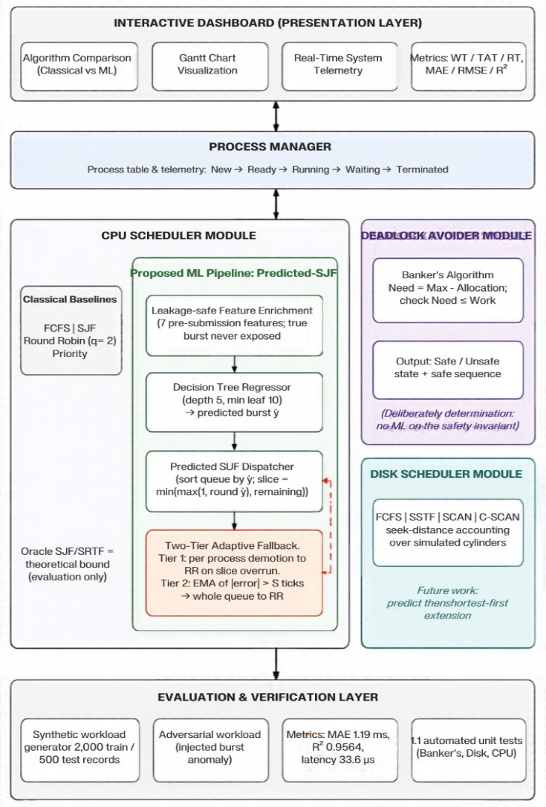
Fig. 1. Unified Operating System Resource Management Simulator Architecture.

IV. METHODOLOGY
A. Baseline Scheduling Algorithms
FCFS, SJF, Round Robin (quantum q = 2), and Priority Scheduling are implemented as non-preemptive or preemptive baselines as appropriate, each calculating waiting time Wi = Starti − Arrivali, turnaround time Ti = Completioni − Arrivali, and response time Ri = FirstRuni − Arrivali for each process.
B. ML-Based Burst-Time Prediction
A Decision Tree Regressor (max depth 5, minimum samples per leaf 10, squared-error criterion) is trained on a seven-dimensional pre-submission feature vector: requested memory (MB), static priority, historical burst average, three lagged past-burst values, and a categorical process-type attribute (interactive, bursty, batch). An early implementation defaulted all missing telemetry to identical dummy values, leading to every process to traverse the same decision-tree leaf and receive an identical prediction regardless of their true burst time. This was diagnosed as a degenerate-input problem and not a model defect, and resolved by an enrichment function which synthesizes realistic, process-type-conditioned memory and priority values together with autoregressive past-burst histories with bounded multiplicative noise, following the leakage-safe feature design of [4]. Critically, the enrichment function never exposes the true future burst time to the model, preserving the realism of the prediction task.
C. Predicted-SJF Scheduling
At each scheduling decision point, the ready queue is sorted by predicted burst time (not actual burst time, which is not known at dispatch) and each process is given a bounded execution slice: slice = min(max(1, round(ŷ)), remaining), to avoid unbounded execution on any one prediction.
D. Two-Tier Adaptive Fallback Mechanism
The tier 1 (process-level) downgrades a process to the Round Robin queue if its predicted slice is exhausted without completion, namely when its actual burst exceeds ŷi. The tier 2 (workload-level) keeps an online Exponential Moving Average of absolute prediction error, EMAk = α·|Actualk − Predictedk| + (1−α)·EMAk−1 with α = 0.3, and downgrades the entire ready queue to the Round Robin whenever EMA exceeds a threshold (5 ticks in this implementation) to let it cool down. This is a rule-based simplification of the learned expert-routing approach proposed in [5], whose complete scheduling decision flowchart is depicted in Fig. 2.
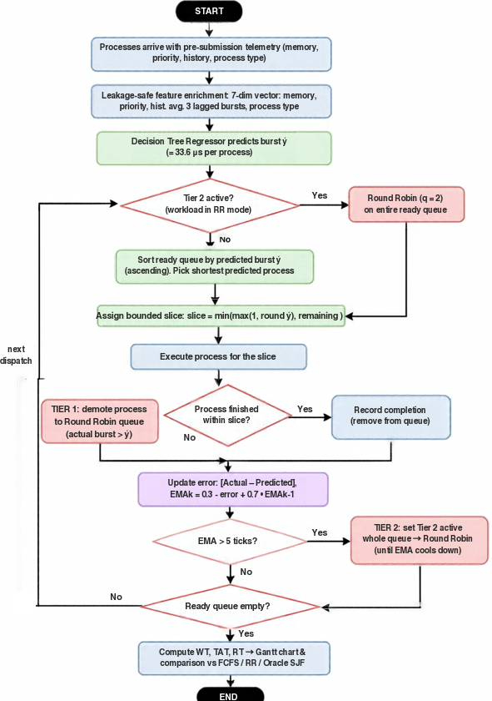
Fig. 2. Flowchart of ML-Augmented CPU Scheduling with Two-Tier Adaptive Fallback Mechanism.
E. Deadlock Avoidance Module
Banker's algorithm is implemented exactly as described by Dijkstra: Need[i][j] = Max[i][j] − Allocation[i][j], and for each unfinished process checking that Need[i] ≤ Work. We have deliberately left the implementation fully deterministic: introducing machine learning-based prediction of future max claims risks both incurring false-negative predictions (allocating requests leading the system to an unsafe state) and false-positive ones (unnecessarily denying safe allocations). This decision is motivated also by [11]: while machine learning is suggested as an offline anomaly detector, it does not replace the online safety invariant (see Fig. 3 for the interface execution and safe sequence verification).
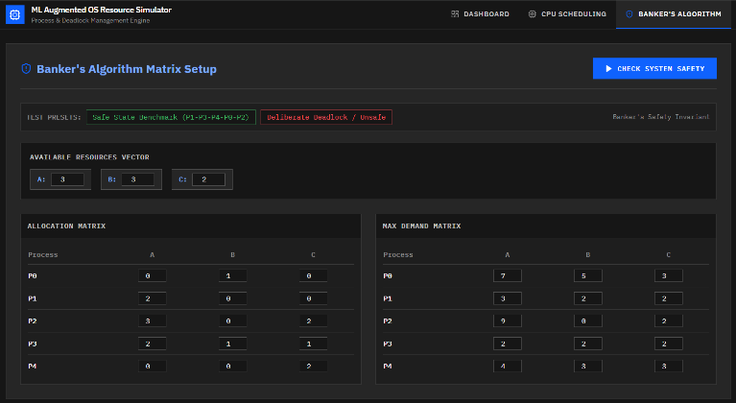
Fig. 3. Deadlock Avoidance Interface executing Banker's Algorithm with Safe State Sequence.
F. Disk Scheduling Module
FCFS, SSTF, SCAN, and C-SCAN disk-scheduling algorithms were implemented with standard seek-distance accounting in a simulated cylinder range. In the same spirit as [12], we propose a predict-then-shortest-first extension to this module, which is structurally analogous to the CPU scheduling approach and discussed as future work in Section VII.
V. EXPERIMENTAL SETUP
The burst-prediction model was trained on 2,000 synthetically generated process records sampled from a mixture of distributions (exponential in the case of interactive processes, Gaussian for batch processes, and a Pareto, α = 1.5, for bursty processes) using a fixed random seed. The evaluation was performed on an exclusive, sequentially partitioned subsequent block of 500 records from the same generator stream with a deliberately injected burst anomaly to probe fallback resilience. All scheduling comparisons were conducted against the same process streams, across all five policies under test, to ensure a controlled comparison
VI. RESULTS AND EVALUATION
A. Model Validation
On the held-out test set, the model has a Mean Absolute Error of 1.19 ms, Root Mean Squared Error of 2.21 ms, and a coefficient of determination R 2 of 0.9564. The measured inference latency is 5.80 μs for raw decision-tree traversal and 33.6 μs end-to-end through the serving pipeline, comfortably within a 50 μs dispatch budget.
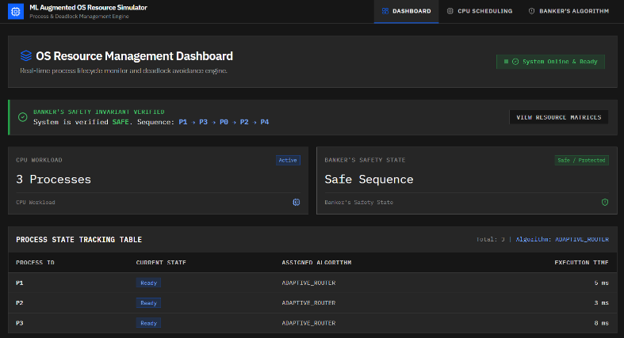
Fig. 4. Real-Time Web Dashboard providing unified monitoring across system components.
Metric | Value
MAE | 1.19 ms
RMSE | 2.21 ms
R² | 0.9564
Tree inference | 5.80 μs
Pipeline inference | 33.6 μs
Table I. Burst-time prediction model validation metrics.
B. Comparative Scheduling Performance
Table II provides the mean waiting and turnaround time over a representative set of batches (N = 5) using the FCFS, Round Robin, Predicted-SJF, and theoretical Oracle SJF scheduling algorithms. Predicted-SJF reduces the mean waiting time by 31.4% compared to FCFS in this batch, and matches Oracle SJF exactly for this particular workload; however, the measured Oracle Gap over a range of stochastic workloads varies from 0.0% to 3.6%, and the total reduction in mean waiting time compared to FCFS over all tested batches is between 20-35%.
Policy | Avg. WT (ms) | Avg. TAT (ms)
FCFS | 10.2 | 15.4
Round Robin (q=2) | 11.8 | 17.0
Predicted-SJF (ML) | 7.0 | 12.2
Oracle SJF (ideal) | 7.0 | 12.2
Table II. Comparative scheduling performance (WT = waiting time, TAT = turnaround time).
Because Oracle SJF requires perfect knowledge of burst time, unavailable to any practical scheduler, operating at a few percent of this theoretical optimum is the main empirical claim of this work, not the percentage reduction over FCFS it implies (see Fig. 4 for the overall dashboard overview, and Fig. 5 for the live Predicted-SJF execution timeline and performance breakdown).

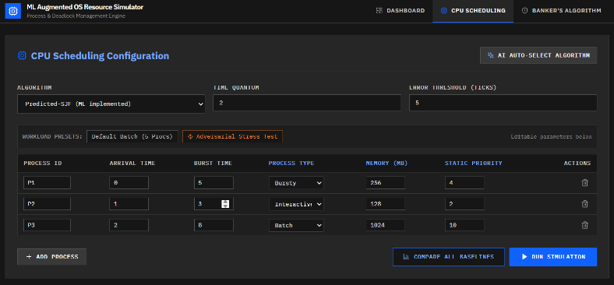
Fig. 5. ML-Augmented CPU Scheduling module displaying Predicted-SJF execution, interactive process telemetry, real-time Gantt timeline, and turnaround metrics.
C. Adversarial Fallback Evaluation
A carefully adversarial workload was constructed in which several processes exhibit deceptive low-burst telemetry (which prompt short predicted bursts near 2.8 ms) while having true bursts of 18-24 ms. In such a workload, Tier 1 correctly demotes the offending process upon slice exhaustion, and sustained error drives the EMA above the 5.0-tick threshold, prompting Tier 2 and reverting the entire ready queue to Round Robin. This confirms that catastrophic starvation (the primary risk of trusting a misled predictor) is bounded in both the single-process and workload-wide case.
D. Automated Verification
An automated test suite comprising eleven-unit tests was executed to verify the correct functioning of all three subsystems. Of these, three tests pertain to the Banker's algorithm: one tests a textbook safe-state scenario, other tests an unsafe/deadlock scenario, and the third tests a boundary condition. Four tests evaluate the correctness of the seek-distance calculation for FCFS, SSTF, SCAN, and C-SCAN scheduling algorithms by comparing the results to hand-crafted references. Finally, four tests pertain to the CPU-scheduling subsystem, verifying the correctness of the multi-algorithm comparison engine, the adversarial circuit breaker, and the model validation endpoint (R² > 0.90, MAE < 2.0 ms, latency < 50 μs). All eleven tests passed.
VII. DISCUSSION AND SCOPE
Two choices in scope warrant specific comment. Firstly, Banker's Algorithm was retained as purely deterministic, rather than enhanced with ML, because the cost of a false-negative safety assessment (a missed path to deadlock) is demonstrably more severe than any gain in throughput a learned predictor could provide; this parallels the treatment of deadlock-related machine learning in [11], where it is considered an offline, advisory layer, not an online replacement for a safety invariant. Secondly, disk scheduling was implemented classically, with an ML extension identified for future work rather than core scope, as the predict-then-shortest-first pattern validated for CPU scheduling in this work has an established, structurally analogous precedent for I/O scheduling in [12], but had not yet been implemented and evaluated within the time constraints of this project.
A limitation of the present evaluation is that while the test set is strictly held out from the training procedure, it is nonetheless drawn from the same continuous generator stream and underlying distributional family as the training set. Generalization to structurally different workload distributions or to a real production trace is left for future work.
VIII. CONCLUSION AND FUTURE WORK
The paper introduced an ML-enhanced CPU scheduler inside a unified OS resource management simulator; the Decision Tree Regressor predicted the burst time of processes and a two-stage adaptive fallback mechanism controlled the risks of wrong predictions. The method demonstrated the accuracy and gains comparable to the recent works in the literature in terms of scheduling and utilized the strict real-time budget for the inference task. The future research will adopt the predict-then-shortest-first paradigm for the I/O disk scheduling as suggested in [12], compare the performance of a small multilayer perceptron and the decision tree to directly evaluate the tradeoff between accuracy and interpretability suggested in [8], and apply the method to the multicore scheduling scenario as described in [10].
REFERENCES
[1] T. Helmy, S. Al-Azani, and O. Bin-Obaidellah, “A machine learning-based approach to estimate the CPU-burst time for processes in the computational grids,” in Proc. IEEE AIMS, 2015.
[2] “CPU Burst-Time Estimation using Machine Learning,” in Proc. IEEE DELCON, 2022.
[3] “Predicting CPU Burst Times with ML to Enhance Shortest Job First (SJF) and Shortest Remaining Time First (SRTF) CPU Scheduling,” 2025. [Online]. Available: ResearchGate, Publication No. 397058205.
[4] “Leakage-Safe and Scheduler-Aware Machine Learning for Grid Job Runtime Prediction,” arXiv:2609.13701, 2025.
[5] “Mixture-of-Schedulers: An Adaptive Scheduling Agent as a Learned Router for Expert Policies,” arXiv:2511.11628, Nov. 2025.
[6] “KernelOracle: Predicting the Linux Scheduler's Next Move with Deep Learning,” arXiv:2505.15213, May 2025.
[7] “Aegis: A Learning-Based Linux Scheduler,” arXiv:2510.08479, Oct. 2025.
[8] “Machine Learning for Energy-Performance-aware Scheduling,” arXiv:2601.23134, Jan. 2026.
[9] “Machine Learning for Scheduling: A Paradigm Shift from Solver-Centric to Data-Centric Approaches,” arXiv:2512.22642, Dec. 2025.
[10] “CPU scheduling: from classical heuristics to learning-based and multicore paradigms: a systematic review,” Computing, Springer, 2026.
[11] “Using Deep Learning for Deadlock Detection in Intelligent Software Systems,” in Proc. IEEE, 2025.
[12] A. Joukov et al., “Towards Machine Learning-Based I/O Scheduling,” Stony Brook Univ. & Harvey Mudd College, Tech. Rep. FSL-25-07, 2025.

